PLC Based Four Floor Elevator Control System
Project Report
Design Implementation and Simulation Testing
Shailesh Dhakal
Electrical Engineering
University of South Florida
Project period July 2026 to August 2026
Additional testing completed October 15 2026

Tools: Allen-Bradley Micro850 Simulator, Rockwell Automation Connected Components Workbench, and Ladder Logic. This report documents state-based control, fault diagnostics, the travel watchdog correction, and 23 functional simulation checks.

1 Project Summary and Objectives
I developed and tested a four floor elevator controller in Rockwell Automation Connected Components Workbench using the Allen-Bradley Micro850 Simulator. The controller stores floor requests, selects travel direction, updates simulated floor feedback, and coordinates arrival with door opening, dwell, and closing. Fault handling records a fault code, disables operation, clears pending requests, and requires an allowed reset followed by a fresh Start command.
The completed test sequence covered normal operation, multiple requests, requests added during travel, Stop and restart behavior, emergency stop, invalid position, a blocked travel watchdog, and conditional reset. The final tests confirmed emergency stop shutdown between floors at position 248 and successful resumption of a paused trip using its stored request. All cases in the planned functional checklist passed after the corrections described in this report.
The completed scope is a PLC simulation project. Position and door feedback are generated by ladder logic; the project does not include a physical elevator, commissioned digital I/O, or a completed HMI. The emergency stop function is a scanned software fault response. No asynchronous interrupt execution or physical safety certification was tested.

Objectives
- Implement a repeatable state sequence for four floors using ladder logic.
- Capture momentary calls and preserve requests until service or fault clearing.
- Select the nearest pending destination in the retained direction when idle.
- Prevent travel commands unless the simulated door is closed and operation is enabled.
- Distinguish normal Stop from a latched fault and verify deliberate restart.
- Inject representative faults and verify shutdown, fault codes, blocked reset, and recovery.

Project Accomplishments
- Developed state-based ladder logic for four-floor operation, stored requests, directional destination selection, door sequencing, and motion interlocks.
- Implemented fault-code diagnostics, a travel watchdog, and conditional reset; corrected premature watchdog timeouts and retested normal and blocked-travel operation.
- Executed and documented 23 functional simulation checks covering travel, door sequencing, injected faults, blocked reset, and deliberate restart.

2 System Architecture and Operating Sequence
Component | Implementation
Engineering software | Rockwell Automation Connected Components Workbench Standard Edition
Controller environment | Micro850 simulator
Program structure | MainTask → Program1 → Prog1 ladder routine
Floor model | Four positions represented by 0, 100, 200, and 300
Door model | Sim_DoorPosition from 0 closed to 100 open
Time base | TON_SimTick preset T#100ms
Door dwell | TON_Dwell preset T#3s
Travel watchdog | TON_Travel final preset T#60s

State | Meaning | Next action
0 | Idle | Serve the current floor or select a destination
10 | Upward travel | Stop at or beyond the locked target
11 | Downward travel | Stop at or below the locked target
20 | Door opening | Advance when Door_Open is TRUE
30 | Door dwell | Run the dwell timer while enabled
40 | Door closing | Return to idle when Door_Closed is TRUE
99 | Latched fault | Wait for an accepted reset

The normal sequence is idle, travel, door opening, dwell, door closing, and idle. A call at the current floor skips travel and enters the door sequence directly. Normal Stop disables operation while retaining the active travel state and destination. A fault overrides the sequence with state 99 and clears the stored requests.
Current_Floor identifies the most recent floor reached. Between floor positions, At_Floor is FALSE while Current_Floor retains its previous valid value. This is why Current_Floor remained 3 when the E-stop test stopped at position 248.

3 Controller Tags and Feedback
Tag or group | Type | Purpose
Start_PB, Stop_PB | BOOL | Enable operation or pause it
EStop_Active, Reset_PB | BOOL | Inject E-stop and request fault reset
Call_Floor1 to Call_Floor4 | BOOL | Floor call inputs
Run_Enable | BOOL | Sealed operating permission
Req1 to Req4 | BOOL | Stored pending requests
State | INT | Sequence state
Last_Direction | INT | 1 upward and 2 downward
Sim_Position | INT | Simulated car position
Current_Floor | INT | Last reached floor from 1 to 4
Target_Position | INT | Locked travel destination or −1 when none
Sim_DoorPosition | INT | Simulated door travel from 0 to 100
Motor_Up, Motor_Down | BOOL | Travel commands
Door_Opening, Door_Closing | BOOL | Door commands
At_Floor1 to At_Floor4, At_Floor | BOOL | Derived floor feedback
Door_Open, Door_Closed | BOOL | Derived door end positions
Call1_Prev to Call4_Prev | BOOL | Previous scan values for call edges
Req_Here, Req_Above, Req_Below | BOOL | Request location summaries

Position | Floor feedback
0 | At_Floor1 TRUE and Current_Floor 1
100 | At_Floor2 TRUE and Current_Floor 2
200 | At_Floor3 TRUE and Current_Floor 3
300 | At_Floor4 TRUE and Current_Floor 4

The floor positions are simulation units, not measured physical distances. Door_Closed is derived from Sim_DoorPosition = 0, and Door_Open from Sim_DoorPosition = 100. The final build uses Sim_Position; tags from earlier project versions are not used as the naming basis of this report.

4 Ladder Logic Implementation

Request Capture and Dispatch
Each call is compared with its previous scan value. A rising call while enabled latches its associated Req bit. Releasing the call does not cancel the stored request. The corresponding request is cleared when the door opening state is active at that floor. Keeping a call TRUE does not repeatedly create new requests without another rising edge.
While idle, Req_Here takes priority. Otherwise, Last_Direction is retained when requests remain in that direction. If no request remains ahead but one exists behind, the direction reverses. Destination selection chooses the nearest pending floor in the selected direction. Target_Position remains locked during travel, so an additional call is stored for a later decision rather than changing the active target.

Travel and Door Interlocks
Motor_Up requires enabled operation, no E-stop, a closed door, state 10, a position below the target, and a position below 300. Motor_Down uses state 11 with the corresponding greater-than comparisons and the lower position limit of 0. The simulation updates position by 2 units per tick when the selected motor command is active and travel is not blocked.
Arrival uses greater-than-or-equal for upward travel and less-than-or-equal for downward travel. The controller then enters state 20. Door commands require enabled operation, valid floor feedback, no E-stop, and both motor commands OFF. Door position changes by 5 units per tick. The sequence advances at the open end position, completes the dwell timer, closes the door, and returns to state 0.

Fault and Reset Processing
Fault detection precedes the main sequence. Fault_Code is written only when it is zero, retaining the first recorded cause. A nonzero code latches Fault_Active, sets state 99, clears Req1 through Req4, and removes Run_Enable. Codes are 1 for E-stop, 2 for invalid position, and 3 for travel timeout.
Reset uses a rising edge. Reset_Allowed requires a latched fault, cleared fault causes, no travel block, valid floor feedback, a closed door, Start and Stop released, and both position test fixtures released. An accepted reset clears the code and fault and returns to idle. Run_Enable remains FALSE until a fresh Start edge.

5 Test Method and Initialization
I tested the program through the CCW live variable table. The Logical Value column was used for results. Initial Value describes download initialization and can differ from a tag’s current live value. The red numeric text in the live table was not treated as an error indication.
In the available workflow, I switched to PROGRAM to change Boolean inputs, then returned to RUN so the controller could scan the new values. Numeric initialization changes were made through a new download. Tests involving retained requests or paused travel used the same download throughout the sequence.
A momentary input was represented by TRUE during a RUN interval followed by FALSE during a later RUN interval. For edge based Start and Reset, the controller first had to scan the released FALSE level before a new TRUE could create another pulse. Reset_Prev and Start_Prev were maintained by the program rather than used as operator controls.
Baseline tag | Initial value
State, Sim_Position, Sim_DoorPosition, Fault_Code | 0
Current_Floor, Last_Direction | 1
Target_Position | −1
Project BOOL tags | FALSE unless explicitly enabled for a test
TON_Travel preset | T#60s in the final version

For a fresh floor 1 to floor 4 trip, Start_PB and Call_Floor4 were initialized TRUE. Sim_BlockTravel, Sim_InvalidPosition, Sim_ReturnFloor1, EStop_Active, Stop_PB, and Reset_PB were FALSE. Derived feedback and output bits were allowed to update through the ladder logic.

Simulation Fault Fixtures
Sim_BlockTravel prevents position changes while leaving an active travel sequence available to the watchdog. Sim_InvalidPosition writes 301 while no fault is latched. Sim_ReturnFloor1 restores position 0 during a fault under its permissive conditions. These fixtures support testing and recovery; they do not represent a physical homing system.
The tests below record the observed transitions and stable end values. The configured dwell is 3 seconds; the opening, dwell, and closing sequence was observed, but an independent measurement of the exact dwell duration was not taken. PROGRAM mode input changes demonstrate fault response on resumed scanning rather than measuring continuous RUN response latency.

6 Baseline Floor Feedback and Single Trips

Test 1 Idle initialization
Procedure. Start with the baseline values and enter RUN without Start.
Result. The controller remained idle with Run_Enable FALSE, no stored requests, closed doors, and travel outputs OFF. Status: Passed.

Test 2 Start seal in
Procedure. Apply Start, allow RUN scanning, then release Start and run again.
Result. Run_Enable became TRUE and remained TRUE after Start was released. The controller did not need Start to remain held. Status: Passed.

Test 3 Upward travel and floor feedback
Procedure. Request floor 2 from floor 1 and allow the complete door cycle.
Result. Sim_Position reached 100, Current_Floor became 2, At_Floor2 was TRUE, and the other floor bits were FALSE. The request cleared and the controller finished idle with the door closed. Status: Passed.

Test 4 Downward travel
Procedure. From floor 2, request floor 1 and complete the sequence.
Result. Position returned to 0, Current_Floor became 1, Last_Direction was 2, and the controller finished in state 0 with no fault and all motion outputs OFF. Status: Passed.
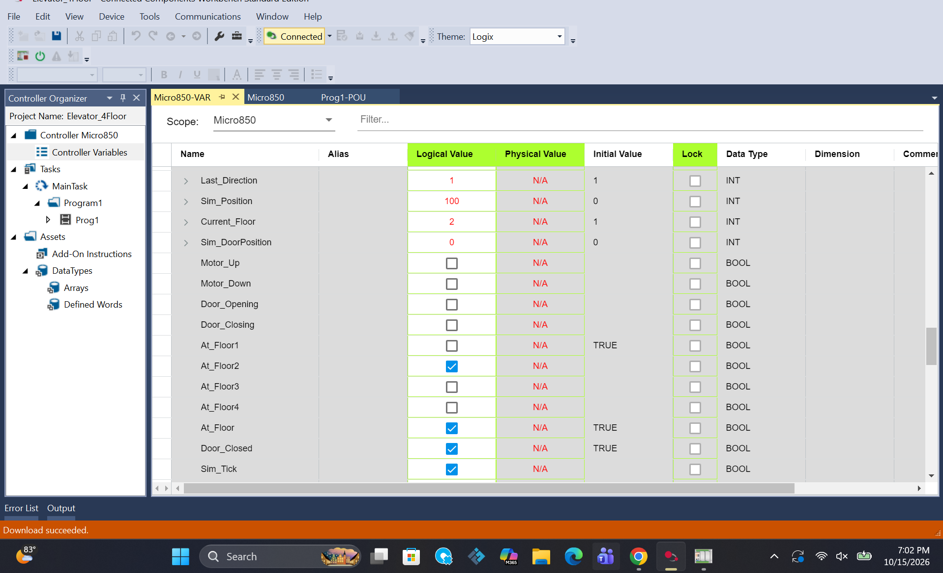
Figure 1. Floor 2 feedback after upward travel with position 100 and the door closed.

7 Stored Requests and Directional Service

Test 5 Multiple pending calls
Procedure. From floor 1, register floor 2, 3, and 4 requests together. Observe each stop and the final request bits.
Result. The observed service order was floor 2, then 3, then 4. Req4 cleared last. The completed run ended at position 300 with all stored requests FALSE and Fault_Code 0. Status: Passed.

Test 6 Release a call during travel
Procedure. Start a floor 1 to floor 4 trip, then release Call_Floor4 before arrival.
Result. The stored request remained effective after the input was released. The trip and door cycle completed at floor 4, and Req4 cleared after service. Status: Passed.

Test 7 Add a request during travel
Procedure. During a downward trip from floor 4 toward floor 1, register a floor 3 call. Repeat using the corrected 60 second watchdog.
Result. The controller retained the added request, completed the active destination, then served the additional call. The final live values were position 200, Current_Floor 3, state 0, and all requests FALSE. Status: Passed.
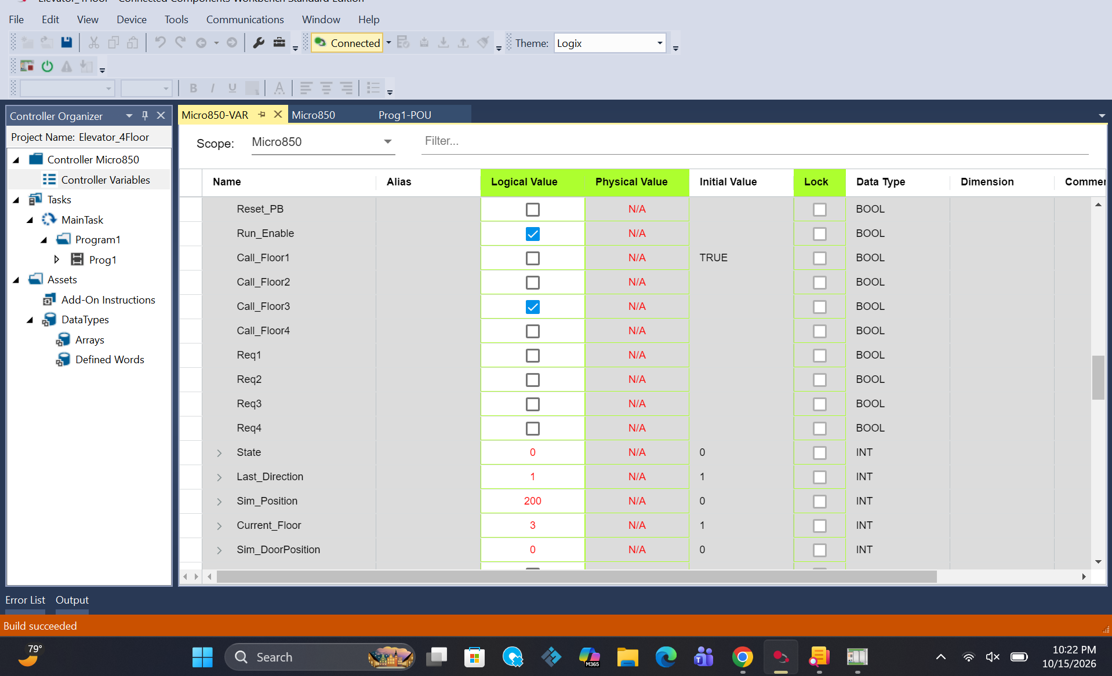
Figure 2. Completed additional request at floor 3 with no stored requests remaining.
This behavior is directional request selection with a locked active target. It is not a first-in first-out queue, and the added call does not imply an immediate stop at an intermediate floor during the active trip.

8 Door Sequence and Normal Stop

Test 8 Call at the current floor
Procedure. Register a floor 1 call while already at floor 1.
Result. The door sequence ran without travel. The motor commands remained OFF and the current-floor request was cleared during service. Status: Passed.

Test 9 Door opening dwell and closing
Procedure. Observe State and Sim_DoorPosition during a service cycle.
Result. The door position progressed from 0 to 100 and back to 0. The opening, dwell, and closing transitions occurred, and the controller returned to idle. The configured dwell preset was T#3s. Status: Passed.

Test 10 Stop while idle
Procedure. At floor 4 after a completed run, apply Stop and then release it while Start remains FALSE.
Result. Run_Enable became FALSE. Releasing Stop did not enable operation or create a new trip. Status: Passed.

Test 11 Stop during travel
Procedure. During travel from floor 3 toward floor 1, set Stop TRUE, release Start, and release the call input. Resume RUN.
Result. Travel paused, Run_Enable became FALSE, the active state and stored destination were retained, and position stopped changing. Motor and door outputs were OFF without a fault. Status: Passed.

Test 12 Release Stop without Start
Procedure. Release Stop during the same paused sequence and return to RUN with Start FALSE.
Result. The controller remained paused. The stored request remained available, but operation did not restart until a fresh Start was supplied. Status: Passed.

Interpretation
Normal Stop preserves the trip so it can be resumed deliberately. Fault shutdown has different behavior: it enters state 99 and clears the request bits. The final combined pause and restart test in Section 12 verified this distinction through a complete trip.

9 Emergency Stop and Fault Latching

Test 13 Emergency stop while idle
Procedure. Apply EStop_Active at idle.
Result. Fault_Code became 1, Fault_Active became TRUE, and the sequence entered state 99. Operation and the travel and door commands were disabled. Status: Passed.

Test 14 Reset with E stop present
Procedure. While EStop_Active remained TRUE, apply a fresh Reset edge and allow scanning.
Result. Reset was rejected. Reset_Allowed stayed FALSE and the fault remained latched with code 1 and state 99. Status: Passed.

Test 15 Emergency stop during travel
Procedure. Repeat the upward trip and apply EStop_Active before arrival. Return to RUN after changing the input in PROGRAM.
Result. The car stopped at position 248 between floors 3 and 4. Fault_Code was 1, Fault_Active TRUE, State 99, and Run_Enable FALSE. All four requests and all motor and door outputs were FALSE. Reset_Allowed was FALSE. Status: Passed.
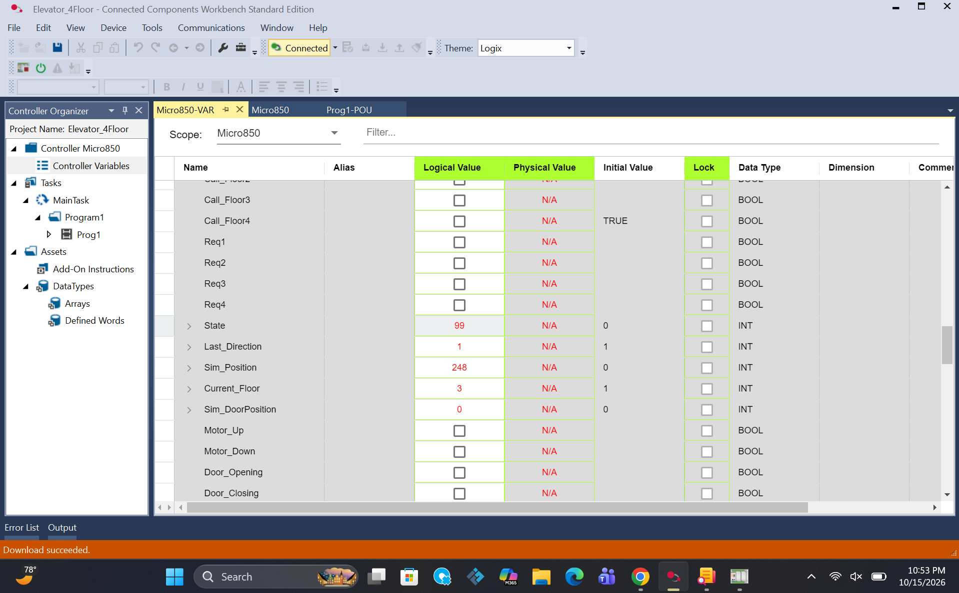
Figure 3. E-stop during travel at position 248 with state 99 and all requests and motion outputs cleared.
The first attempt applied E-stop after reaching floor 4. I repeated the test before arrival; the position 248 result is the completed travel test. Current_Floor retained 3 because floor 3 was the last valid floor reached.

10 Invalid Position Detection and Recovery

Test 16 Invalid position fault
Procedure. Enable Sim_InvalidPosition to produce position 301. Observe the floor feedback and fault values.
Result. The controller detected invalid position, recorded code 2, latched the fault, and entered state 99. Floor feedback was invalid, motion outputs were OFF, and reset was blocked while the cause remained. Status: Passed.

Test 17 Restore a valid floor before reset
Procedure. Release the invalid position fixture, release Start and Reset, and use Sim_ReturnFloor1 during the fault. Then release the return fixture.
Result. Position returned to 0 and floor 1 feedback became valid. Position_Fault cleared while fault code 2 stayed latched until Reset. Once the reset conditions were satisfied, Reset_Allowed became TRUE and an accepted reset returned the system to idle with code 0 and Run_Enable FALSE. Status: Passed.
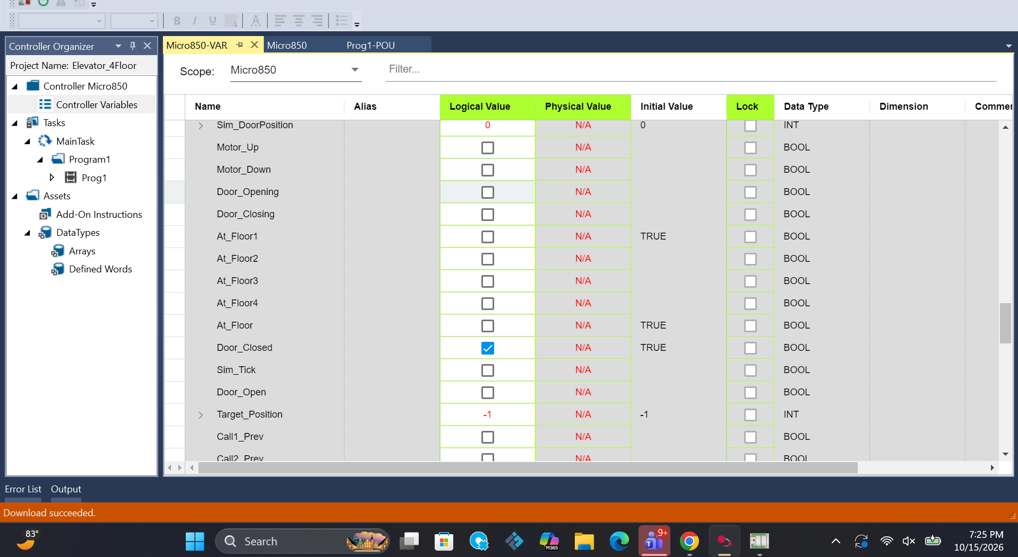
Figure 4. Invalid floor feedback during position fault testing with all At_Floor bits FALSE.

Position Fault Conditions
The position fault logic checks a position greater than 300, a position less than 0, and idle state without a valid floor. Position 301 was the injected test case. The lower-bound and idle-between-floors branches are part of the design; separate injection results for every branch were not recorded in this checklist.
Restoring position during a fault is a controlled simulation recovery action. Clearing Position_Fault alone does not clear Fault_Active. The separate reset step confirms that a disappeared cause cannot automatically restart the sequence.

11 Travel Watchdog and Blocked Reset

Test 18 Blocked travel timeout
Procedure. Start a trip with Sim_BlockTravel TRUE. In the final version, keep the controller in RUN beyond the 60 second watchdog interval.
Result. Position remained 0. The timeout produced Fault_Code 3, Fault_Active TRUE, and state 99. Stored requests cleared, travel and door outputs were OFF, and Reset_Allowed was FALSE. Status: Passed.

Test 19 Reset while travel remains blocked
Procedure. Keep Sim_BlockTravel TRUE and apply a fresh Reset edge.
Result. The reset was rejected. Code 3 and state 99 remained, Fault_Active stayed TRUE, and operation remained disabled. Status: Passed.

Test 20 Remove travel block and reset
Procedure. Release Reset and Sim_BlockTravel, allow a RUN scan, then apply a fresh Reset with the remaining permissives satisfied.
Result. Reset_Allowed became TRUE. The accepted reset cleared the code and fault and returned State to 0. Run_Enable remained FALSE and required a fresh Start. Status: Passed.
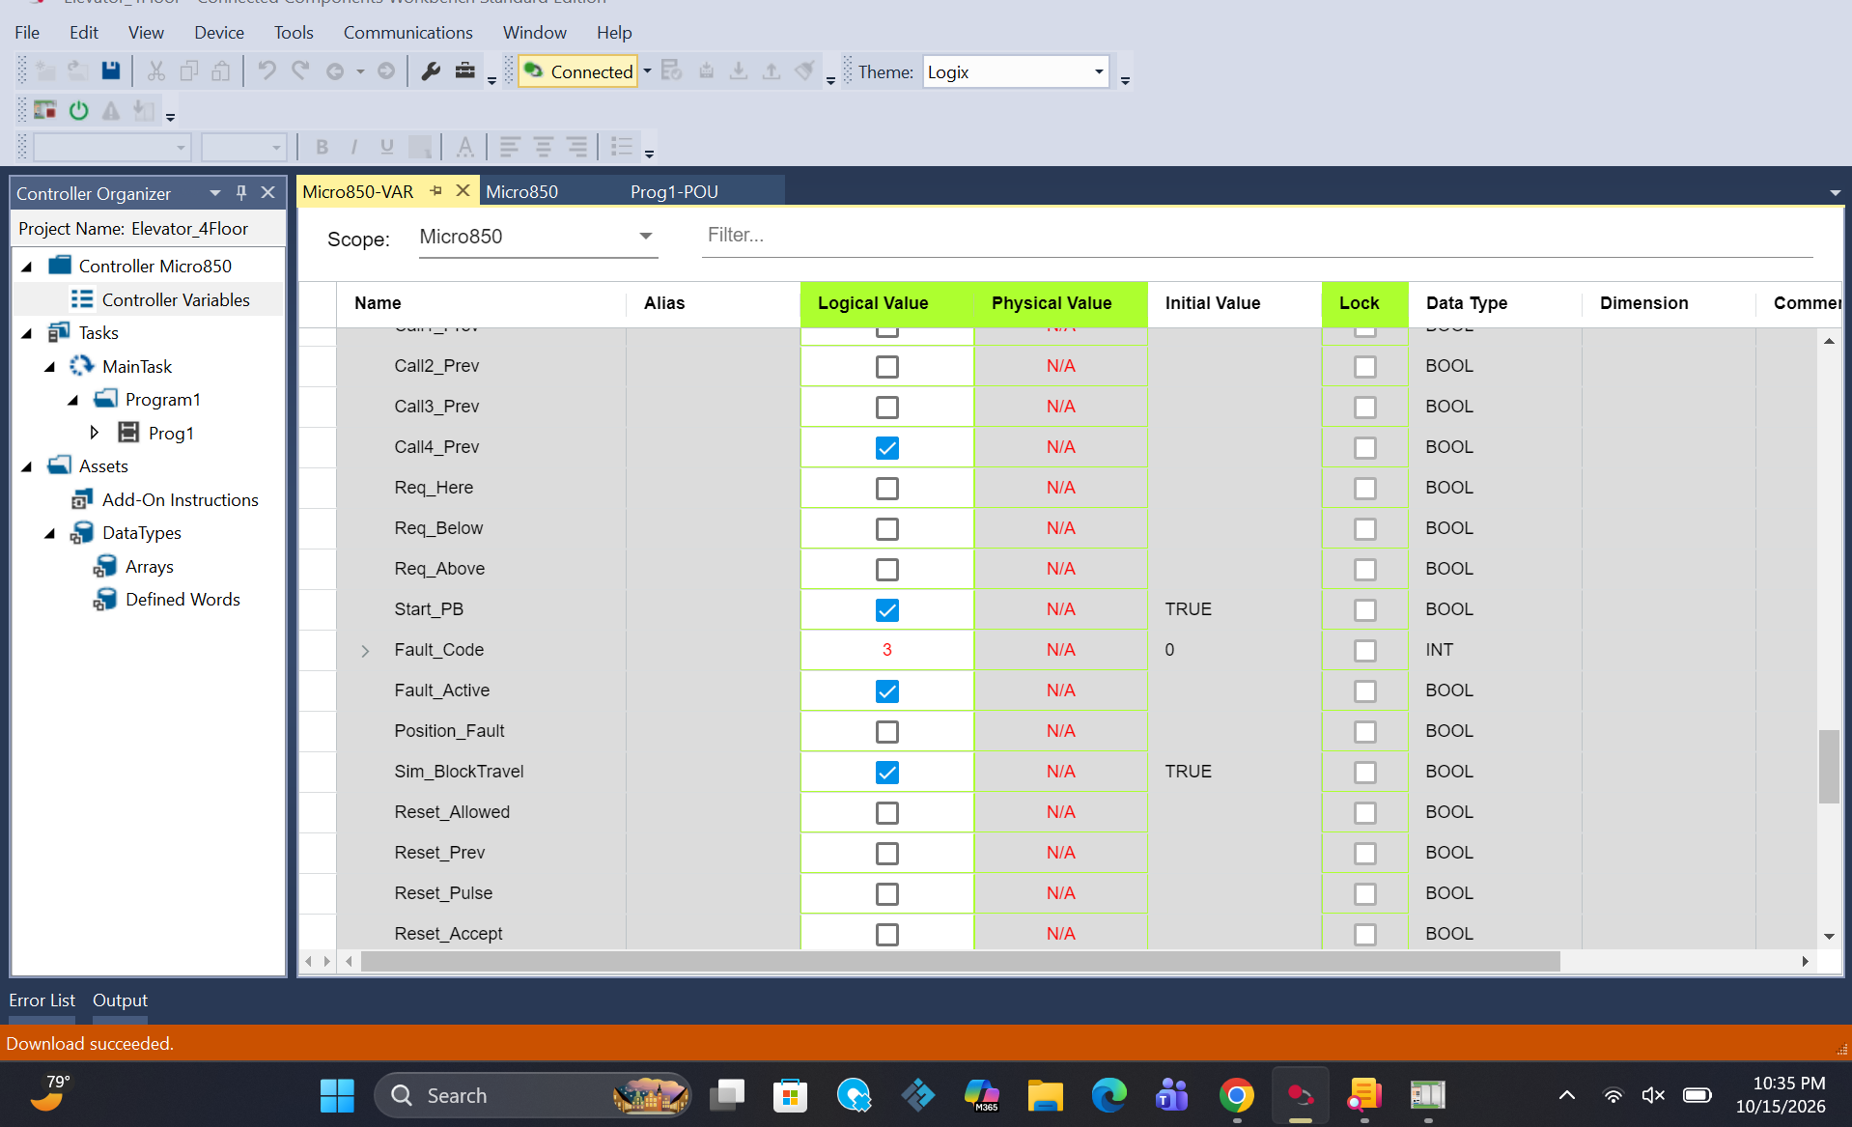
Figure 5. Final watchdog fault with code 3 and Sim_BlockTravel TRUE after the 60 second test.
The initial preset was 30 seconds. A valid long downward trip timed out near position 12, so the margin was insufficient for the simulator workflow. I increased the preset to T#60s, repeated normal request service, and repeated the blocked travel test successfully. This screenshot shows the final fault values; the 60 second interval was checked during the run.

12 Reset Edges and Complete Pause Resume Test

Test 21 Reset edge and no automatic restart
Procedure. Release the fault cause and Reset, allow RUN scanning, and then apply Reset TRUE in a later RUN interval.
Result. The fault cleared to code 0 and state 0 while Run_Enable remained FALSE. Reset_Prev followed the input after scanning. Holding Reset TRUE did not create repeated fresh reset edges. Status: Passed.

Test 22 Fresh Start after fault reset
Procedure. After a successful fault reset, apply a fresh Start edge with normal permissives present.
Result. Operation could be enabled again deliberately. Reset alone did not start the controller. Status: Passed.

Test 23 Complete Stop release and Start resume
Procedure. Use one download for a floor 1 to floor 4 trip. During travel, apply Stop, release Start, and release Call_Floor4. Run while stopped; release Stop and run again with Start FALSE. Finally apply a fresh Start and let the trip finish.
Result. While paused, State remained 10, Req4 TRUE, Target_Position 300, and Run_Enable FALSE. Releasing Stop alone did not resume travel. A fresh Start resumed the stored trip with Call_Floor4 still FALSE. The final position was 300, Current_Floor 4, State 0, and door position 0. Requests and motion outputs were FALSE, with code 0 and no active fault. Status: Passed.

Final Test Outcome
All three phases of Test 23 matched the expected values. No new download was used between pausing and resuming, so the result verified preservation of the active trip rather than reinitialization. This was the last remaining case in the planned functional checklist.

Reset Screenshot
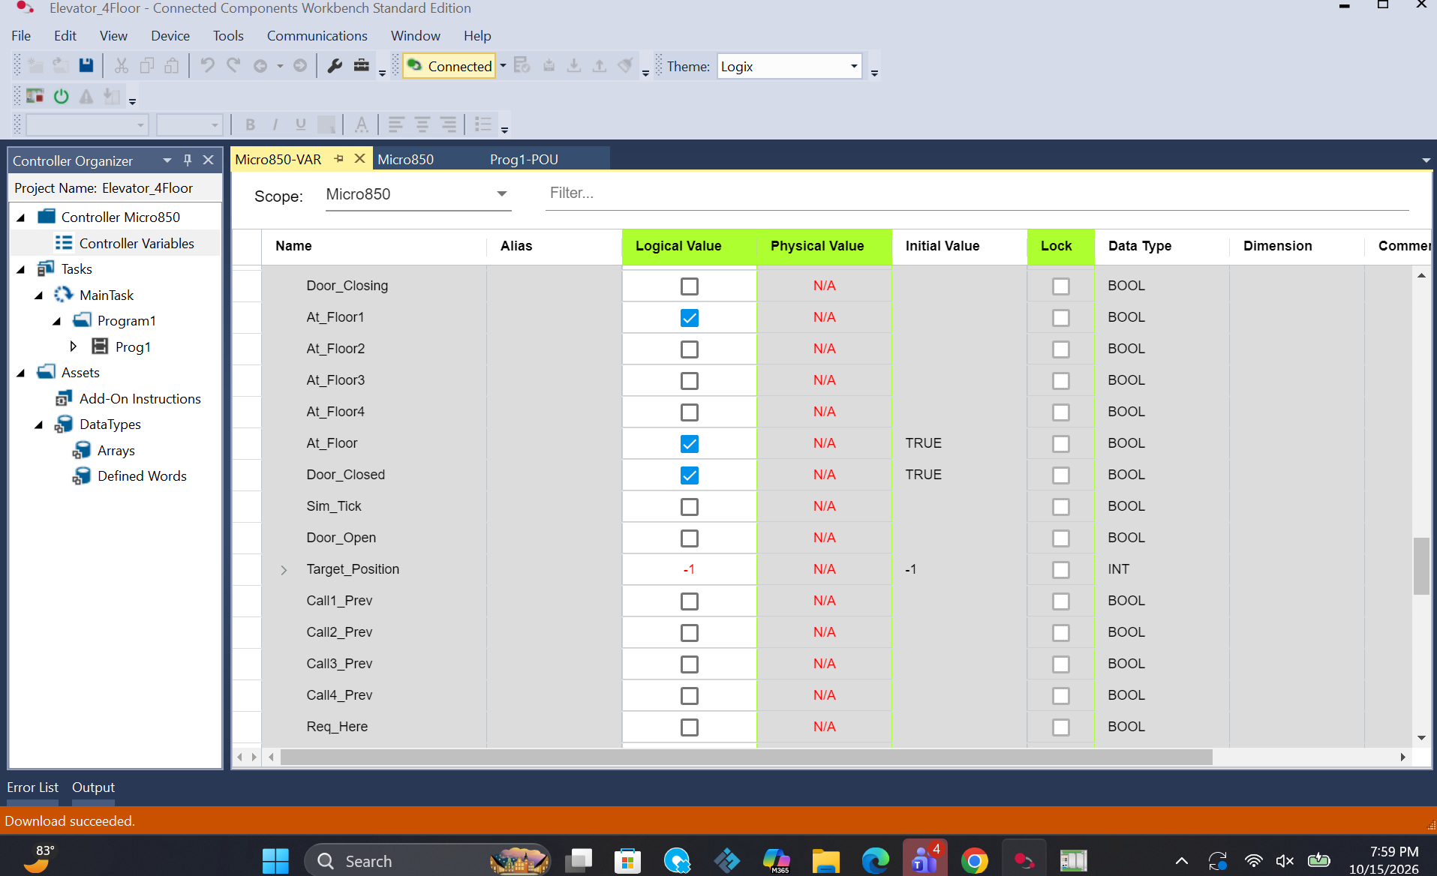
Figure 6. Recovered floor 1 feedback with Target_Position −1 and the door closed during reset verification.

13 Consolidated Test Results
Test | Check | Result
1 | Idle initialization | Passed
2 | Start seal in after release | Passed
3 | Upward trip and floor 2 feedback | Passed
4 | Downward trip to floor 1 | Passed
5 | Multiple calls and directional order | Passed
6 | Stored call survives input release | Passed
7 | Additional request during travel | Passed
8 | Current floor call without travel | Passed
9 | Door opening dwell closing sequence | Passed
10 | Idle Stop and no automatic restart | Passed
11 | Stop during travel | Passed
12 | Stop release stays paused | Passed
13 | E-stop at idle | Passed
14 | Reset blocked with E-stop present | Passed
15 | E-stop during travel at position 248 | Passed
16 | Injected invalid position 301 | Passed
17 | Valid floor recovery and reset | Passed
18 | Blocked travel timeout at final preset | Passed
19 | Reset blocked while travel blocked | Passed
20 | Watchdog cause removal and reset | Passed
21 | Reset edge and restart prevention | Passed
22 | Fresh Start after fault reset | Passed
23 | Full paused trip resume and completion | Passed

The 23 entries organize the completed checklist into individual functional checks; several were performed within the same run. They do not represent 23 independent downloads or a quantified reliability test. Passing this checklist establishes the observed simulation behavior within the tested conditions.

14 Discussion Comparison and Conclusions

Comparison with the Reference Elevator Project
Reference feature | Completed project implementation
RSLogix 5000 and Allen-Bradley PLC | CCW ladder logic for the Allen-Bradley Micro850 simulator. RSLogix 5000 was not used.
Multi-floor state automation | Four floors with idle, travel, opening, dwell, closing, and fault states.
Prioritized floor queuing | Stored request bits with current-floor priority and nearest destination selection in the retained direction. The active target remains locked.
Directional control and timed transitions | Up and down commands, simulated position feedback, door sequencing, configured dwell, and a travel watchdog.
Modular PLC logic | One ladder routine organized into functional sections rather than separate reusable routines.
Emergency interrupt and asynchronous reset | Scanned E-stop fault handling and conditional edge based reset. No asynchronous interrupt is implemented.
Digital I/O modules and rotary switches | Boolean inputs and simulated feedback. Physical I/O wiring and rotary switches are outside the completed build.

The project achieves the reference’s main sequencing and fault-handling learning goals using the Rockwell environment available for this build. The remaining differences come from the selected Micro850 simulation platform, the single-routine structure, and the absence of a physical elevator and I/O hardware. These are scope differences rather than failed tests.

Conclusions
I developed state-based ladder logic for four-floor operation and completed 23 functional simulation checks for the controller. The final build stored and served requests, completed upward and downward trips and door cycles, paused and resumed a stored trip, and shut down with the expected codes for the tested E-stop, invalid position, and travel timeout faults. Conditional reset prevented recovery with active test causes and required a deliberate Start afterward.
The completed deliverable is a tested ladder logic simulation suitable for explaining PLC sequencing, interlocks, fault diagnosis, and recovery. Exact timing measurements, exhaustive fault combinations, hardware commissioning, and HMI integration remain separate work. A physical passenger elevator would require a dedicated engineered safety system beyond this educational simulation.

Appendix A Program Organization and Evidence Index
Rungs | Function
1 to 2 | Invalid position and return to floor 1 simulation fixtures
3 to 15 | Floor feedback, door feedback, and simulation tick
16 to 20 | Position fault, travel watchdog, and fault code capture
21 to 26 | Fault latch, fault state, and request clearing
27 to 35 | Reset and Start edges and reset acceptance
36 | Run_Enable seal in with Stop and fault conditions
37 to 42 | Arrival detection, motor commands, and position updates
43 to 50 | Door state transitions, dwell, and door position updates
51 to 62 | Call capture, previous values, and request clearing
63 to 77 | Request summaries, direction, target selection, and dispatch

The rung map describes the final second-build organization discussed during implementation. The screenshots below are indexed by their original supplied filenames so the displayed evidence can be located without confusing earlier tests with final retests.
Figure 1: image(20261015-230202).png. Floor 2 feedback after upward travel with position 100 and the door closed.
Figure 2: image(20261016-022209).png. Completed additional request at floor 3 with no stored requests remaining.
Figure 3: image(20261016-025358).png. E-stop during travel at position 248 with state 99 and all requests and motion outputs cleared.
Figure 4: image(20261015-232511).png. Invalid floor feedback during position fault testing with all At_Floor bits FALSE.
Figure 5: image(20261016-023555).png. Final watchdog fault with code 3 and Sim_BlockTravel TRUE after the 60 second test.
Figure 6: image(20261015-235915).png. Recovered floor 1 feedback with Target_Position −1 and the door closed during reset verification.

Evidence Notes
The images are embedded from the supplied PNG files in their original colors without grayscale conversion, recoloring, or fading. The Windows taskbar is cropped from each screenshot to hide its clock and date. Report text, headings, table rules, and page numbering use black or neutral gray. Live screenshots capture stable values; the test descriptions also record the transitions observed during execution. The final pause and resume result was confirmed during the test and has no separate final screenshot in this report.

Appendix B Fault Tags and Timer Settings
Tag | Type | Function
Fault_Code | INT | 0 none, 1 E-stop, 2 position, 3 travel timeout
Fault_Active | BOOL | Latched fault status
Position_Fault | BOOL | Live position validity result
Sim_BlockTravel | BOOL | Travel failure injection
Sim_InvalidPosition | BOOL | Position 301 injection
Sim_ReturnFloor1 | BOOL | Controlled simulated position recovery
Reset_Allowed | BOOL | Combined reset permissives
Reset_Prev | BOOL | Reset input from previous scan
Reset_Pulse | BOOL | One scan rising Reset detection
Reset_Accept | BOOL | Reset pulse with permissives satisfied
Start_Prev | BOOL | Start input from previous scan
Start_Pulse | BOOL | One scan permitted Start detection
Sim_Tick | BOOL | Periodic simulation update pulse
TON_SimTick | TON | Configured preset T#100ms
TON_Dwell | TON | Configured preset T#3s
TON_Travel | TON | Final configured preset T#60s

Conditions Required for Reset
Reset_Allowed is TRUE only when Fault_Active is TRUE, EStop_Active is FALSE, Position_Fault is FALSE, TON_Travel.Q is FALSE, Sim_BlockTravel is FALSE, At_Floor is TRUE, Door_Closed is TRUE, Start_PB and Stop_PB are FALSE, and Sim_InvalidPosition and Sim_ReturnFloor1 are FALSE. Reset_Pulse must then become TRUE for Reset_Accept to occur.
The travel watchdog is enabled when State is 10 or 11, Run_Enable is TRUE, and Fault_Active is FALSE. A normal Stop removes the watchdog enable, so it is a watchdog for enabled travel rather than a cumulative timer across a paused trip.

